**SPRINT-4**

|  |  |
| --- | --- |
| **TEAM ID** | **PNT2022TMID43101** |
| **Project Name** | **IoT Based smart crop Protection system for agriculture** |
| **Maximum mark** | **20 marks** |

1.The random sensor data’s are generated and automation has been implemented through the python code instead of using hardware to implement IOT based crop protection system

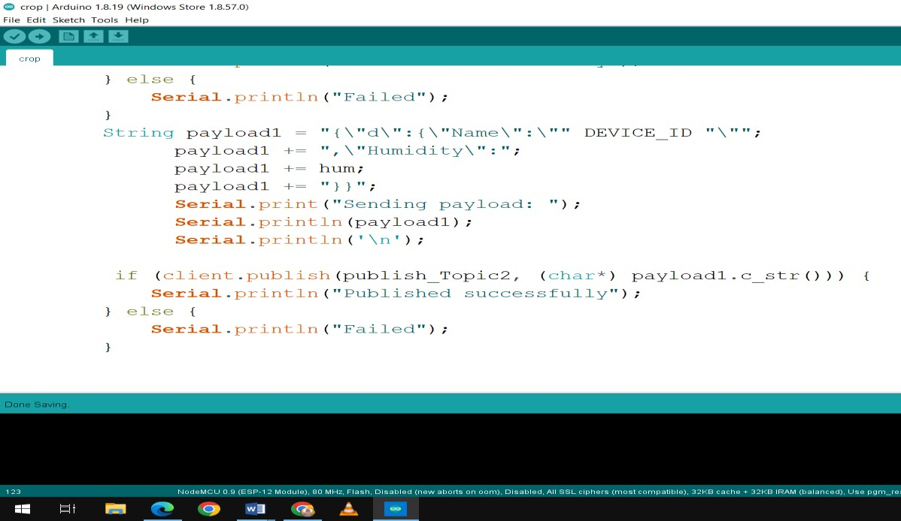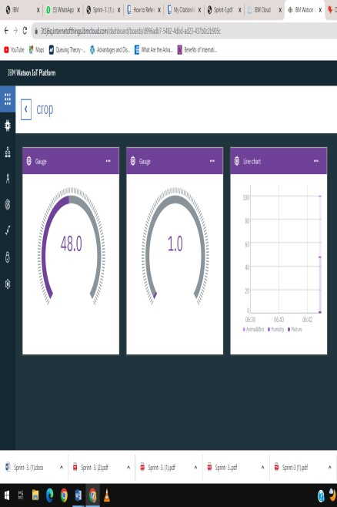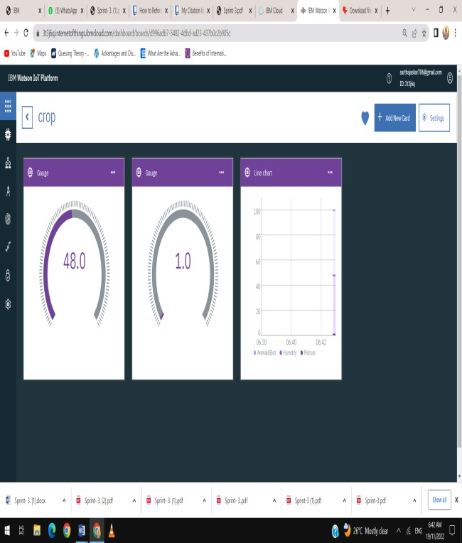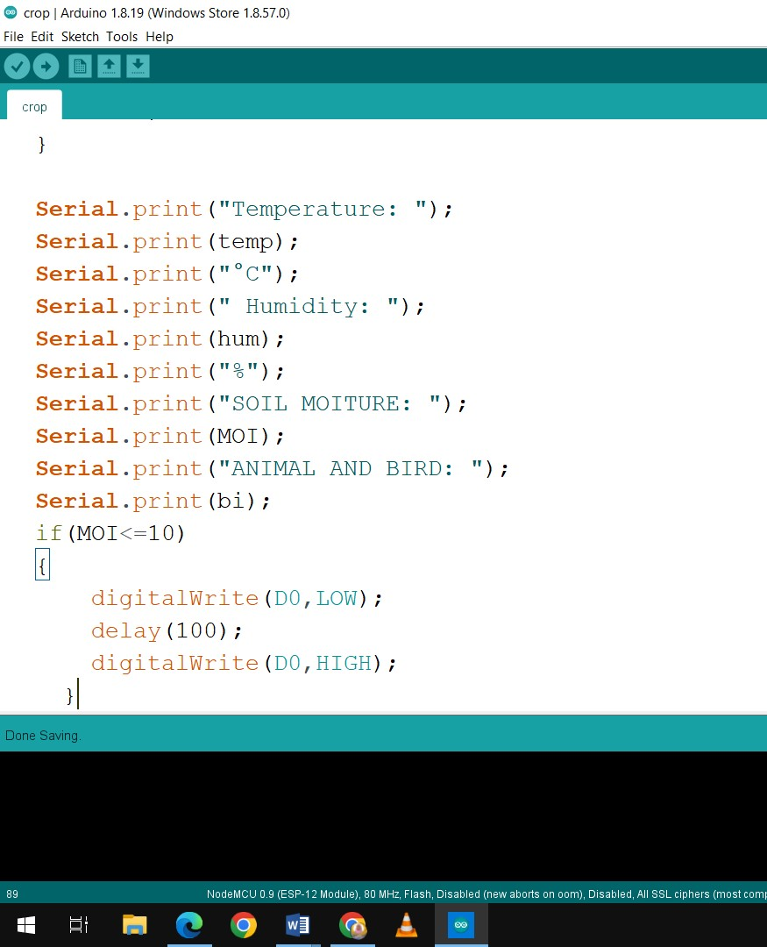

2.This system uses a motion sensor to detect wild animals approaching near the field. In such a case the sensor signals the microcontroller to take action.

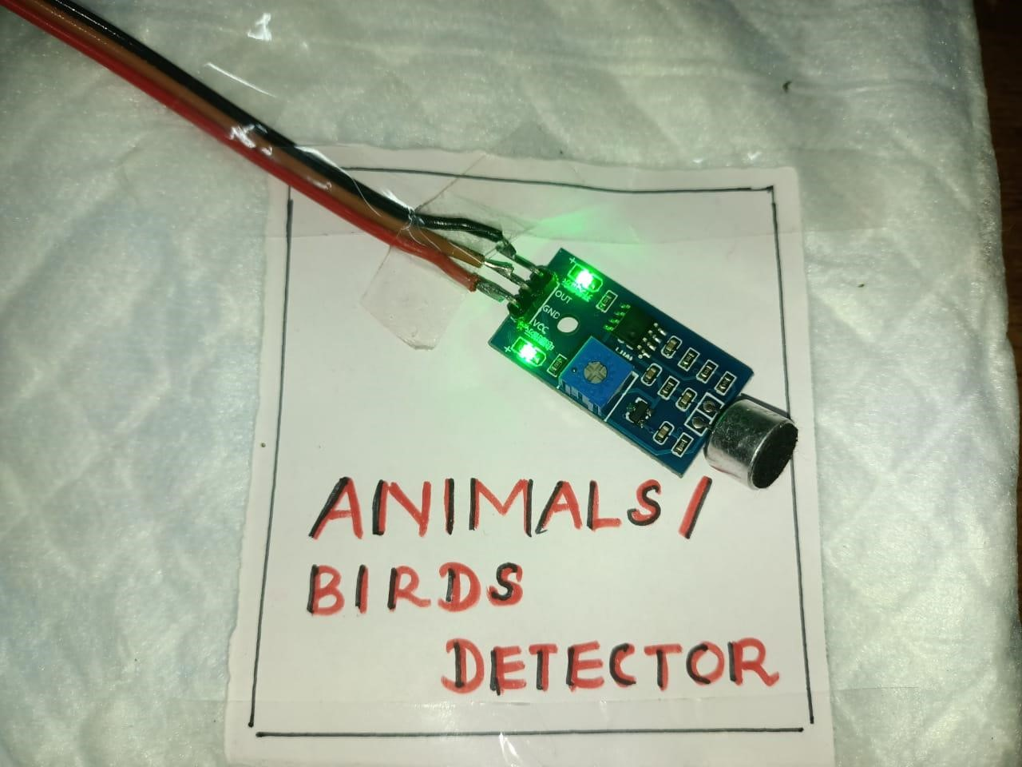

3.**Soil moisture sensors** measure the volumetric water content in soil. Since the direct gravimetric measurement of free soil moisture requires removing, drying, and weighting of a sample, soil moisture sensors measure the volumetric water content indirectly by using some other property of the soil, such as electrical resistance, dielectric constant, or interaction with neutrons, as a proxy for the moisture content

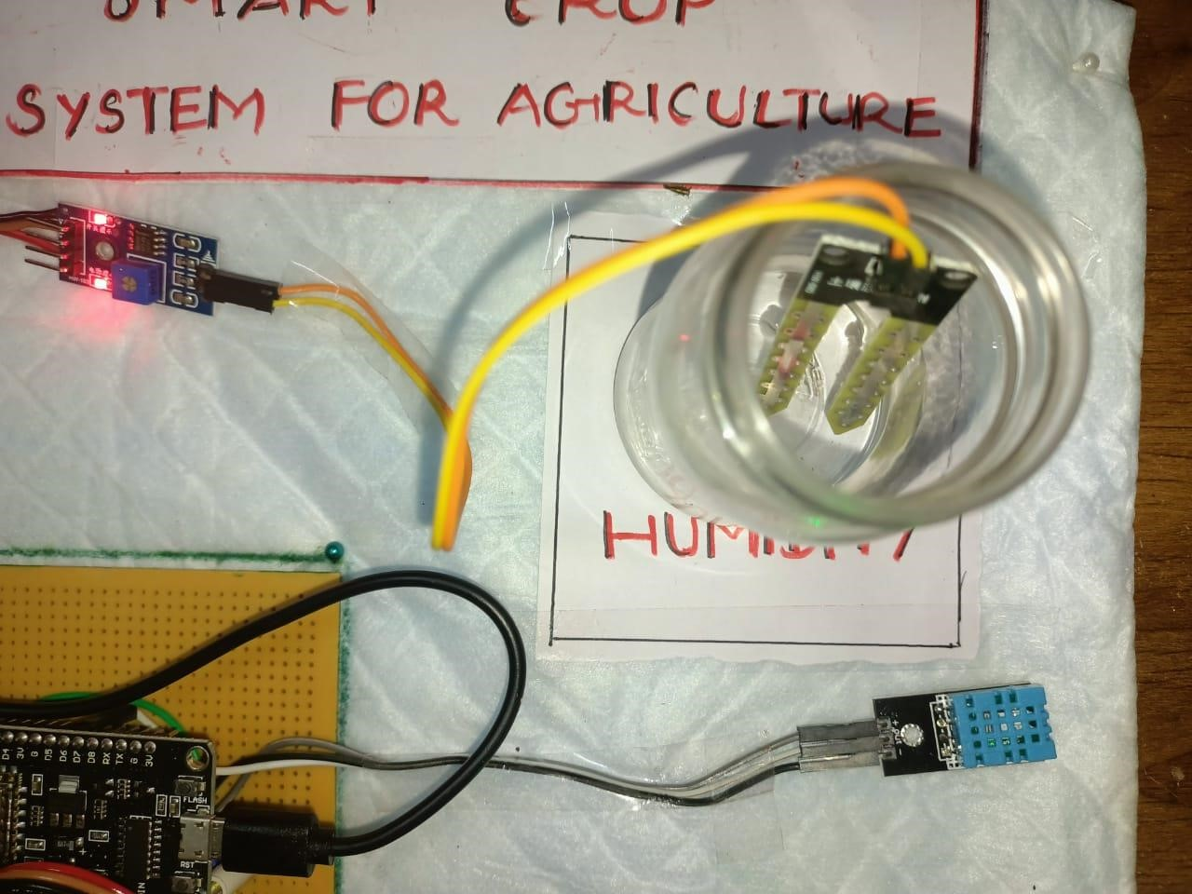

4. The IOT device is used to indicate the farmer by a message while someone enter into the farm and we are used SD card module that helps to store a specified sound to fear the animals. This project is smart crop protection system for protect the farm from animals as well as unknown person.

